DKT224
D
ata Communications & Network
sem2 08/09
Page
1
of
4
Tutorial
#2
DUE:
Feb27th
, 200
9
in
Tutorial
class
NOTE : all questions are from your text book.
Chapter 4
1 (
11) What are the differences between parallel and serial transmission?
In parallel transmission we send data
several bits at a time.
In serial
transmission
we send data
one bit at a time.
2 (
12) List three differences techniques in serial transmission and explain the
differences.
Three differences techniques in serial transmission are
synchronous,
asynchronous, and isochro
nous. In both synchronous and asynchronous
transmissions, a bit stream is divided into independent
frames. In synchronous
transmission, the bytes inside each frame are synchronized; in asynchronous
transmission, the bytes inside each frame are also indepen
dent. In isochronous
transmission, there is no independency at all. All bits in the
whole stream must
be synchronized.
3 (
2
7
)
What is the Nyquist sampling rate for each of the following signals?
a.
A low
-
pass signal with bandwidth of 200 KHz?
F
s
=
2 x F
m
= 2 x 200 = 400 K samples/sec.
OR
In a low
-
pass signal, the minimum frequency 0. Therefore, we have
fmax = 0 + 200 = 200 KHz. →fs = 2 × 200,000 = 400,000 samples/s
b.
A band
-
pass signal with bandwidth of 200 KHz if the lowest frequency is
100 KHz?
fmax = 100 + 200 = 300 KHz. →fs = 2 × 300,000 = 600,000 samples /s
4 (
29
)
What is the maximum data rate of a channel with a bandwidth of 200 KHz if
we use four levels of digital signaling?
The maximum data rate can be calculated as
Nmax =
2 × B × nb = 2 × 200 KHz × log2 4 = 800 kbps

Describe the goals of multiplexing.
1.
Multiplexing is the set
of techniques that allow
s the simultaneous transmission
of
multiple signals across a single data link.
In multiplexing, the word link refers to the physical path. The word channel
refers
to the portion of a link that carries a transmission betwee
n a given pair of
lines.
One link can have many (n) channels.
The goals of multiplexing is to maximize the efficiency of their infrastructure,
7 (
2) List and describe the three main muxtiplexing technique .
We discussed frequency
-
division mul
tiplexing (FDM), wave
-
division
multiplexing (WDM), and time
-
division multiplexing (TDM).
FDM and WDM are used to combine analog signals; the bandwidth is
shared.TDM is used to combine digital signals; the time is shared.
8 (
9
)
Distinguish bet
ween synchronous and statistical TDM.
In synchronous TDM, each input has a reserved slot in the output frame. This can
be inefficient if some input lines have no data to send. In statistical TDM, slots are
dynamically allocated to improve bandwidth effic
iency. Only when an input line
has a slot’s worth of data to send is it given a slot in the output frame

We combine six 200
-
kbps sources into three 400
-
kbps. Now we have seven 400
-
kbps channel.
a. Each output frame carries 1 bit from each of the seven 400
-
kbps line. Frame
size = 7 × 1 = 7 bits.
b. Each frame carr
ies 1 bit from each 400
-
kbps source. Frame rate = 400,000
frames/s.
c. Frame duration = 1 /(frame rate) = 1 /400,000 = 2.5 μs.
d. Output data rate = (400,000 frames/s) × (7 bits/frame) = 2.8 Mbps. We can also
calculate the output data rate as the sum of in
put data rate because there is no
synchronizing bits. Output data rate = 6 × 200 + 4 × 400 = 2.8 Mbps.
11 (
21
)
Two channels, one with a bit rate of 190 kbps and another with a bit rate of
180 kbps, are to be multiplexed using pulse stuffing TDM with no
sy
nchronization bits. Answer the following questions:
a.
What is the size of a frame in bits?
b.
What is the frame rate?
c.
What is the duration of a frame?
d.
What is the data rate?
DKT224
D
ata Communications & Network
sem2 08/09
Page
4
of
4
We need to add extra bits to the second source to make both rates = 190 kbps. Now
we
have two sources, each of 190 Kbps.
a. The frame carries 1 bit from each source. Frame size = 1 + 1 = 2 bits.
b. Each frame carries 1 bit from each 190
-
kbps source. Frame rate = 190,000
frames/s.
c. Frame duration = 1 /(frame rate) = 1 /190,000 = 5.3 μs.
d. Output data rate = (190,000 frames/s) × (2 bits/frame) = 380 kbps. Here the
output bit rate is greater than the sum of the input rates (370 kbps) because of
extra bits added to the second
TT

What is Multiplexing?
Multiplexing is the process of combining multiple signals into one signal, over a shared medium. If analog signals are multiplexed, it is Analog Multiplexing and if digital signals are multiplexed, that process is Digital Multiplexing.
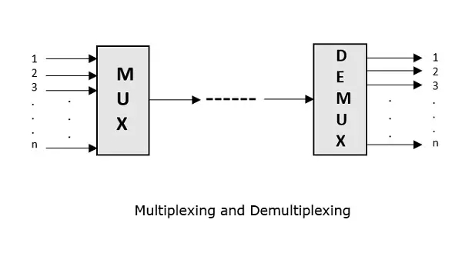
The process of multiplexing divides a communication channel into several number of logical channels, allotting each one for a different message signal or a data stream to be transferred. The device that does multiplexing can be simply called as a MUX while the one that reverses the process which is demultiplexing, is called as DEMUX.
Advertisement

Types of Multiplexers
There are mainly two types of multiplexers, namely analog and digital. They are further divided into FDM, WDM, and TDM.
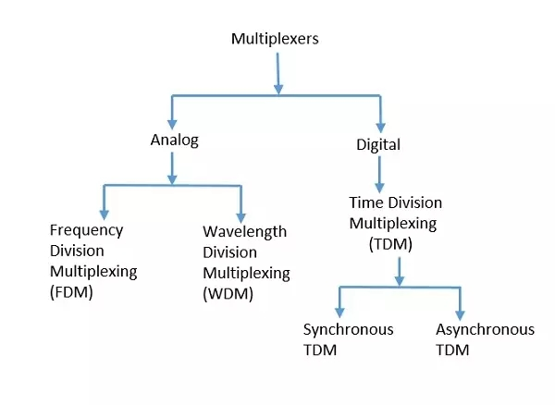

Analog Multiplexing
The analog multiplexing techniques involve signals which are analog in nature. The analog signals are multiplexed according to their frequency (FDM) or wavelength (WDM).

Frequency Division Multiplexing (FDM)
In analog multiplexing, the most used technique is Frequency Division Multiplexing (FDM). This technique uses various frequencies to combine streams of data, for sending them on a communication medium, as a single signal.
Example: A traditional television transmitter, which sends a number of channels through a single cable, uses FDM.

Wavelength Division Multiplexing (WDM)
Wavelength Division Multiplexing is an analog technique, in which many data streams of different wavelengths are transmitted in the light spectrum. If the wavelength increases, the frequency of the signal decreases.
Example: Optical fibre Communications use the WDM technique, to merge different wavelengths into a single light for the communication.

Digital Multiplexing
The term digital represents the discrete bits of information. Hence the available data is in the form of frames or packets, which are discrete.

Time Division Multiplexing (TDM)
In TDM, the time frame is divided into slots. This technique is used to transmit a signal over a single communication channel, with allotting one slot for each message. Of all the types of TDM, the main ones are Synchronous and Asynchronous TDM.

Synchronous TDM
In Synchronous TDM, the input is connected to a frame. If there are n number of connections, then the frame is divided into n time slots. One slot is allocated for each input line. In this technique, the sampling rate is common to all signals and hence same clock input is given. The mux allocates the same slot to each device at all times.

Asynchronous TDM
In Asynchronous TDM, the sampling rate is different for each of the signals and the clock signal is also not in common. If the allotted device, for a time-slot, transmits nothing and sits idle, then that slot is allotted to another device, unlike synchronous.

Time Division Multiplexing
The Time Division Multiplexing (TDM) is a digital procedure. Here, each sender is given the entire possession of the whole bandwidth of the channel for a fixed duration of time. After this, the control is moved to the next sender, and the process continues on a round-robin basis.
An example of TDM is the television broadcast. In a television serial, generally, a 10 minutes' serial is followed by a 5 minutes' advertisement. The time in which the serial is being broadcasted, the total frequency is dedicated to the serial.
Advertisement

Variants of Time Division Multiplexing
The following variants on TDM are as follows
- ATDM (Asynchronous Time Division Multiplexing): Multiplexing in which the data is transmitted asynchronously.
- STDM (Statistical Time Division Multiplexing): A multiplexing method that polls nodes and immediately skips any nodes with nothing to send.
- STM (Synchronous Transfer Node): Designer for use in BISDN (broadband ISDN) and also supported in the SONET (Asynchronous Optical Network) architecture.

Types of Time Division Multiplexing
There are two types of TDM which are as follows

1. Synchronous TDM
Synchronous TDM is known as synchronous and is essential because, each time slot is pre-assigned to a constant source. The time slots are sent irrespective of whether the sources have a few records to share or not.
TDM devices can manage the source of various data rates. This is completed by authorising fewer slots per cycle to the passive input devices than the rapid device.
Both multiplexing and demultiplexing operations for synchronous TDM, are demonstrated in the figure given below.
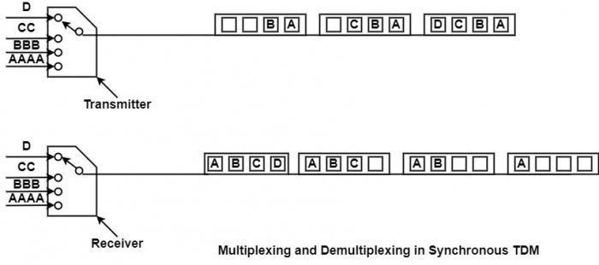

2. Statistical TDM
One disadvantage of the TDM method is that some of the time slots in the frame are wasted. A specific terminal has no information to send to a particular instant of time and will share an unfilled time slot. It is also called asynchronous TDM or intelligent TDM.

Synchronous Time Division Multiplexing
In the Synchronous Time Division Multiplexing (STDM), the multiplexer assigns an equal time slot to every device at all times, whether or not a device has anything to send. Time slot A, for instance, is authorised to device A alone and cannot be used by any other device.
Each time is assigned a time slot and it shows up. Then, a device has the time to transmit a portion of its data. If a device cannot send or does not have data to send, its time slot remains null.
The time slots are consolidated into frames, and every frame includes one or more time slots committed to each sending device. If there are n sending devices, the frame consists of n slots, where each slot will be allocated to each of the sending devices. This happens if all the sending devices transmit at the same rate as shown in the figure.
In the diagram given below, there are four inputs to multiplexer A. Each frame is having four slots corresponding to each of the sending devices.
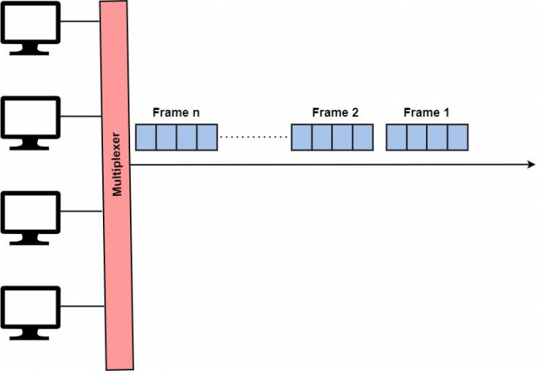
Interleaving
Synchronous Time Division Multiplexing (TDM) can be distinguished to a high-speed rotating switch. As the switch is free in front of a device, that device can transmit a particular record of data onto the direction. The switch transfers from device to device at a fixed price and in a permanent order. This process is called interleaving.
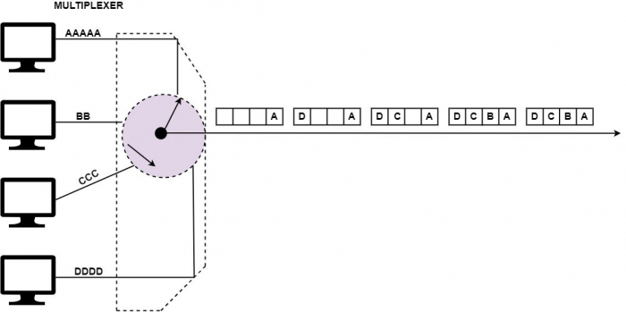
At the receiver, the demultiplexer disintegrates every frame by obtaining each character in turn. As a character is eliminated from a frame, it is moved to the suitable receiving device, as demonstrated in the figure below.
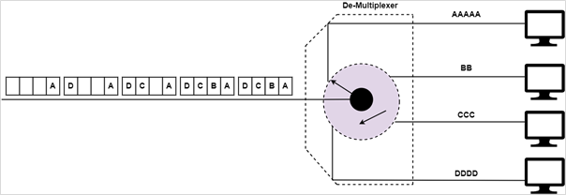
Advertisement

Disadvantage
The disadvantages of Synchronous TDM are as follows
- In synchronous time-division multiplexing, an equal time slot is given to each sender to load its data on the channel.
- Different senders load different volumes of data, and frames are usually empty.

What is Asynchronous TDM
An asynchronous TDM is also called as a Statistical TDM. ATDM has been designed to solve the problem of wastage of the multiplexed channels in synchronous TDM.
Advertisement

Slot Allocation in ATDM
In ATDM, if there are n input lines, then each slot can contain m frames, where m is less than n, as shown in the figure below.
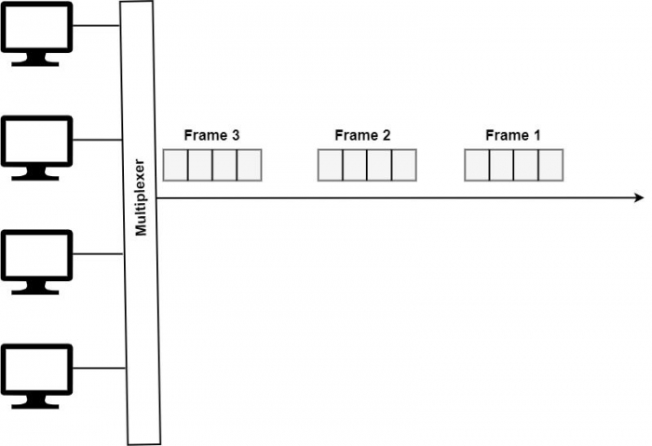

Frame Filling Mechanism
In ATDM, the multiplexer scans all the input lines and accepts the portions of data till the frame is filled. When the frame is filled, it is sent across the link. If the senders don't have enough data to fill the frame, it is transmitted as partially filled. This is depicted in the figure below.
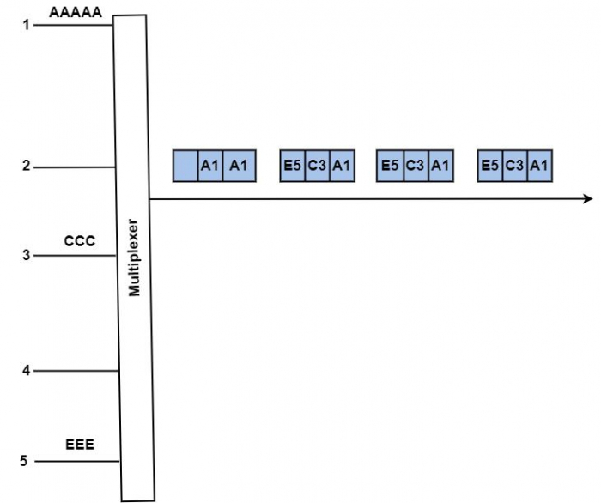

Flexible Slot Usage
Hence, in ATDM, all sending devices can send data in all slots. As we can look from the figure, the slots are variable. Therefore, the receiver cannot identify the characters by counting them.

Addressing in ATDM
An efficient addressing mechanism is required, which should supply a unique address to each time slot. These addresses are temporary and discarded by demultiplexer after reading them correctly.

Asynchronous and Synchronous TDM
The variation between Asynchronous TDM and Synchronous TDM is that few slots in Synchronous TDM are unused, but in Asynchronous TDM, the slots are entirely used. This leads to the shorter transmission time and practical uses of the volume of the medium.
It firmly assigns the time slots on demand to free the input channels. Hence the channel size can be stored. Similarly, as with synchronous TDM, statistical multiplexers can have many input/output (I/O) lines with a buffer related to each of them.
During the input, the multiplexer filters the input buffers and accumulates the record until the frame is filled. Later on the frame is transmitted. At the receiving end, the demultiplexer obtains the frame and circulates the data to the suitable buffer.

Address Overhead in ATDM
In Asynchronous TDM, each slot's data should have an address part, which recognizes the source of information. Therefore, the data arrives from and is circulated to I/O lines unpredictably. The address data is needed to guarantee suitable delivery. This generates extra overhead per slot.

Disadvantages of TDM
One disadvantage of the TDM method is that many of the time slots in the frame are invalid. A specific terminal has no data to transmit instantly and will send an empty time slot.
Adding the address bits to each time slot puts overhead on the system and decreases the system's efficiency.

what is the difference b/w TDM and FDM

s an analog method which is used when the bandwidth of a connection is higher than the linked bandwidth of the signals which are to be communicated
Time Division Multiplexing (TDM) is a digital method where each sender is given the entire possession of the whole bandwidth of the channel for a fixed duration of time. After this, the control is given to the next sender, and the process continues on a round-robin basis.
Read through this article to find out how these two multiplexing techniques work and what are the major differences between TDM and FDM.

What is TDM?
TDM is a technique of transmitting and receiving separate signals across a shared signal path using synchronized switches at either end of the transmission line, with each signal appearing on the line for a fraction of a second in an alternating pattern. This type of signal multiplexing was first devised for telegraphy systems in the late 1800s, but it was most widely used in digital telephony in the second half of the twentieth century.
- TDM uses a shared channel to send two or more digital or analog signals. When the bit rate of the transmission media exceeds the bit rate of the signal to be sent, it can be employed.
- TDM is generally used for digital communications, but it may also be employed in analog multiplexing, in which two or more signals or bitstreams are sent simultaneously as sub-channels in a single communication channel, but take turns on the channel physically.
- Each sub-time channel's domain is split into multiple recurrent time slots of defined length. Sub-channel 1 transmits a sample byte or data block during time slot 1, sub-channel 2 during time slot 2, and so on.
- One TDM frame contains a one-time slot per sub-channel as well as a synchronization channel and, in certain cases, an error correction channel prior to the synchronization.

Types of TDM
There are two types of TDM which are as follows
- Synchronous TDM It is termed "Synchronous" because, each time slot is pre-assigned to a constant source. The time slots are sent irrespective of whether the sources have any records to share or not.
- Statistical TDM A major disadvantage of the TDM method is that some of the time slots in the frame are wasted. If a specific terminal has no information to send at a particular instant of time, then it will share an unfilled time slot. In STDM, the time slots are dynamically allocated to the slots according to demand. The multiplexer checks each input stream in a round-robin manner and allocates a slot to an input line only if data is present there, otherwise, it skips to the next stream and checks it
Advertisement

What is FDM?
FDM is a telecommunications method that divides the overall bandwidth available in a communication channel into a number of non-overlapping frequency bands, each of which carries a distinct signal.
- FDM lets several independent signals share a single transmission channel, such as a cable or optical fiber.
- Separate serial bits or portions of a higher rate transmission can also be carried in parallel.
- Radio and television transmission are the most common examples of FDM, in which several radio signals at various frequencies travel through the air at the same time. Cable television is another example in which many television channels are carried simultaneously on a single cable.
In FDM, different frequencies are combined into a single composite signal and are transmitted on the channel. At the receiver end, the reverse phase is applied to get the individual frequencies back for working. The entire bandwidth of the channel is divided into logical channels, and each sending device is given with the possession of a logical channel.

What is Orthogonal FDM?
In data communications and networking, Orthogonal FDM (OFDM) is a method of digital data modulation, in which a single stream of data is divided into several separate sub-streams for transmission via multiple channels.
OFDM uses the principle of frequency division multiplexing to divide the available bandwidth into a set of sub-streams having separate frequency bands. OFDM was introduced in 1966 by Chang at Bell Labs and was improved by Weinstein and Ebert in 1971.

Disadvantages of Using FDM
There are two major disadvantages in using FDM
- The frequency bands must be separated by guard bands to avoid noise and disruption. This results in bandwidth wastage.
- FDM uses analog signals, which are more prone to noise disruptions than digital signals. So, if there are significant nonlinearities in the transmission link, there could be crosstalk among the different signals, resulting in communication errors.

Difference between TDM and FDM
The following table highlights the major differences between TDM and FDM.
Key | TDM | FDM
Definition | TDM stands for Time Division Multiplexing. | FDM stands for Frequency Division Multiplexing.
Signal | TDM works well with both analog as well as digital signals. | FDM works only with analog signal.
Conflict | TDM has low conflict. | FDM has high conflict.
Wiring | Wiring or Chip of TDM is simpler. | Wiring or Chip of FDM is complex.
Efficiency | TDM is efficient | FDM is quiet inefficient.
Sharing | Time is shared in TDM. | Frequency is shared in FDM.
Required Input | Synchronization pulse is mandatory in TDM. | Synchronization pulse is not mandatory.

Conclusion
TDM and FDM are both multiplexing techniques. FDM is meant for analog signals, while TDM works well with both analog as well as digital signals. However, TDM is mostly used in digital communications only. In TDM, syncronization pulse is important; whereas in FDM, Guard Band is required.

Synchronous TDM
Synchronous TDM is primarily known as synchronous because each time slot is preauthorized to a continuing source. Synchronous TDM is a data transfer approach during which there may be a continuous flow of data signals followed by timing signals. It helps to support that the send and therefore the receiver are synchronized with one another.
The time slots are broadcasted regardless of whether the sources have any information to transmit or not. Thus, for the benefit of the integrity of execution, the channel space is wasted.
Advertisement

Asynchronous TDM
Asynchronous TDM is called statistical division multiplexing. It is a method in which time slots are not permanent as in Synchronous TDM. Time slots are assigned to only those machines which have the information to send the data.
This transmission approach transmits one character or 8 bits at a time. In this approach, before the transmission process begins, each character transfers the beginning bit. After sending the character, it also sends the end bit. With the character bits and begin and stop bits, the entire number of bits is 10 bits.
The major differences between the Synchronous Time Division Multiplexing (STDM) and Asynchronous Time Division Multiplexing (ATDM) are as follows
STDM | ATDM
In synchronous TDM, the unlimited speed of the input lines is never higher than the volume of the direction. | In asynchronous TDM, the total speed of the input lines can be higher than the magnitude of the direction.
Suppose that we have n input lines. The frame includes an endless number of minimum n time slots. | Suppose that we have n input lines. The frame consists of n greater than m slots with m smaller than n.
Synchronous TDM supports less device than asynchronous TDM. | Asynchronous TDM can provide more devices than synchronous TDM.
It provides the equivalent number of input lines as asynchronous TDM with a higher size connection. | It provides an equal number of input lines as asynchronous TDM with a lower size connection.
Due to static allocation, bandwidth is wasted. | Effective utilisation of the line bandwidth.
It is suitable for bit/byte interleaving. | It can use a large unit of data for interleaving.
It can be less overhead for addressing. | It can be a large overhead for addressing.
It accommodates traffic of fixed data costs. | It can accommodate the traffic of shifting data costs by running the dimension of the time slots.
Buffering is not completed, the frame is transmitted after a specific interval of time whether someone has information to send or not. | Buffering is completed and only those inputs are given slots within the output frame whose buffer includes information to send.
In Synchronous TDM, de-multiplexer at receiving end decomposes each frame, removes framing bits, and separates data units successively. This extracted data unit from the frame is then moved to the destination device. | In Asynchronous TDM, de-multiplexer at receiving end decomposes each frame by testing the local address of every data unit. This extracted data unit from the frame is then moved to the destination device.
Synchronization bits are used at the start of every frame. | There are no synchronization bits used.

Frequency Division Multiplexing
Frequency division multiplexing (FDM) is a technique of multiplexing which means combining more than one signal over a shared medium. In FDM, signals of different frequencies are combined for concurrent transmission.
Advertisement

Concept and Process of Frequency Division Multiplexing
In FDM, the total bandwidth is divided to a set of frequency bands that do not overlap. Each of these bands is a carrier of a different signal that is generated and modulated by one of the sending devices. The frequency bands are separated from one another by strips of unused frequencies called the guard bands, to prevent overlapping of signals.
The modulated signals are combined together using a multiplexer (MUX) in the sending end. The combined signal is transmitted over the communication channel, thus allowing multiple independent data streams to be transmitted simultaneously. At the receiving end, the individual signals are extracted from the combined signal by the process of demultiplexing (DEMUX).

Frequency Division Multiplexing Example
The following diagram conceptually represents multiplexing using FDM. It has 4 frequency bands, each of which can carry signal from 1 sender to 1 receiver. Each of the 4 senders is allocated a frequency band. The four frequency bands are multiplexed and sent via the communication channel. At the receiving end, a demultiplexer regenerates the original four signals as outputs.
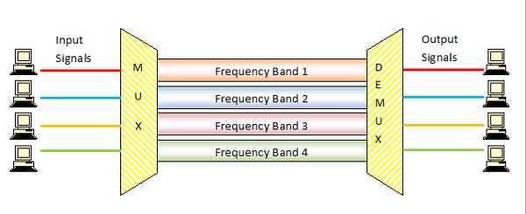
Here, if the frequency bands are of 150 KHz bandwidth separated by 10KHz guard bands, then the capacity of the communication channel should be at least 630 KHz (channels : 150 4 + guard bands : 10 3).

Uses and Applications of Frequency Division Multiplexing
It allows sharing of a single transmission medium like a copper cable or a fiber optic cable, among multiple independent signals generated by multiple users.
FDM has been popularly used to multiplex calls in telephone networks. It can also be used in cellular networks, wireless networks and for satellite communications.

Orthogonal Frequency Division Multiplexing
OFDM is a technique where the channel bandwidth is split into many closely packed sub-carriers or narrowband channels each of which transmits signals independently using techniques like QAM (Quadrature Amplitude Modulation). Consequently, they do not need any guard bands and thus have better utilization of available bandwidth.

Code division multiplexing (CDM) is a multiplexing technique that uses spread spectrum communication. In spread spectrum communications, a narrowband signal is spread over a larger band of frequency or across multiple channels via division. It does not constrict bandwidths digital signals or frequencies. It is less susceptible to interference, thus providing better data communication capability and a more secure private line.

Code Division Multiple Access
When CDM is used to allow multiple signals from multiple users to share a common communication channel, the technology is called Code Division Multiple Access (CDMA). Each group of users is given a shared code and individual conversations are encoded in a digital sequence. Data is available on the shared channel, but only those users associated with a particular code can access the data.
Advertisement

Concept
Each communicating station is assigned a unique code. The codes stations have the following properties
- If code of one station is multiplied by code of another station, it yields 0.
- If code of one station is multiplied by itself, it yields a positive number equal to the number of stations.
The communication technique can be explained by the following example
Consider that there are four stations w, x, y and z that have been assigned the codes c_{w} , c_{x}, c_{y} and c_{z} and need to transmit data d_{w} , d_{x}, d_{y} and d_{z} respectively. Each station multiplies its code with its data and the sum of all the terms is transmitted in the communication channel.
Thus, the data in the communication channel is d_{w} . c_{w}+ d_{x} . c_{x}+ d_{y} . c_{y}+ d_{z} . c_{z}
Suppose that at the receiving end, station z wants to receive data sent by station y. In order to retrieve the data, it will multiply the received data by the code of station y which is d_{y}.
data = (d_{w} . c_{w}+ d_{x} . c_{x}+ d_{y} . c_{y}+ d_{z} . c_{z} ) . c_{y}
= d_{w} . c_{w} . c_{y} + d_{x} . c_{x} . c_{y}+ d_{y} . c_{y} . c_{y}+ d_{z} . c_{z} .
c_{y}
=0 + 0 + d_{y} . 4 + 0 = 4d_{y}
Thus, it can be seen that station z has received data from only station y while neglecting the other codes.

Orthogonal Sequences
The codes assigned to the stations are carefully generated codes called chip sequences or more popularly orthogonal sequences. The sequences are comprised of +1 or 1. They hold certain properties so as to enable communication.
The properties are
- A sequence has m elements, where m is the number of stations.
- If a sequence is multiplied by a number, all elements are multiplied by that number.
- For multiplying two sequences, the corresponding positional elements are multiplied and summed to give the result.
- If a sequence is multiplied by itself, the result is m, i.e. the number of stations.
- If a sequence is multiplied by another sequence, the result is 0.
- For adding two sequences, we add the corresponding positional elements.
Let us ascertain the above properties through an example.
Consider the following chip sequences for the four stations w, x, y and z
[+1 -1 -1 +1], [+1 +1 -1 -1], [+1 -1 +1 -1] and [+1 +1 +1 +1]
- Each sequence has four elements.
- If [+1 -1 -1 +1] is multiplied by 6, we get [+6 -6 -6 +6].
- If [+1 -1 -1 +1] is multiplied by itself, i.e. [+1 -1 -1 +1]. [+1 -1 -1 +1], we get +1+1+1+1 = 4, which is equal to the number of stations.
- If [+1 -1 -1 +1] is multiplied by [+1 +1 -1 -1], we get +1-1+1-1 = 0
- If [+1 -1 -1 +1] is added to [+1 +1 -1 -1], we get [+2 0 -2 0].
The commonly used orthogonal codes are Walsh codes.

Wavelength division multiplexing (WDM) is a technique of multiplexing multiple optical carrier signals through a single optical fiber channel by varying the wavelengths of laser lights. WDM allows communication in both the directions in the fiber cable.

Concept and Process of Wavelength Division Multiplexing
In WDM, the optical signals from different sources or (transponders) are combined by a multiplexer, which is essentially an optical combiner. They are combined so that their wavelengths are different.
The combined signal is transmitted via a single optical fiber strand. At the receiving end, a demultiplexer splits the incoming beam into its components and each of the beams is send to the corresponding receivers.
Advertisement

Example of Wavelength Division Multiplexing
The following diagram conceptually represents multiplexing using WDM. It has 4 optical signals having 4 different wavelengths. Each of the four senders generates data streams of a particular wavelength. The optical combiner multiplexes the signals and transmits them over a single long-haul fiber channel. At the receiving end, the splitter demultiplexes the signal into the original 4 data streams.
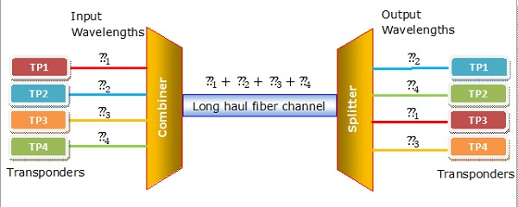

Categories of WDM
Based upon the wavelength, WDM can be divided into two categories
- Course WDM (CWDM) : CWDM generally operates with 8 channels where the spacing between the channels is 20 nm (nanometers) apart. It consumes less energy than DWDM and is less expensive. However, the capacity of the links, as well as the distance supported, is lesser.
- Dense WDM (DWDM) : In DWDM, the number of multiplexed channels much larger than CWDM. It is either 40 at 100GHz spacing or 80 with 50GHz spacing. Due to this, they can transmit the huge quantity of data through a single fiber link. DWDM is generally applied in core networks of telecommunications and cable networks. It is also used in cloud data centers for their IaaS services.

Shortest Path Routing
In this algorithm, to select a route, the algorithm discovers the shortest path between two nodes. It can use multiple hops, the geographical area in kilometres or labelling of arcs for measuring path length.
Advertisement

Labelling of Arcs
The labelling of arcs can be done with mean queuing, transmission delay for a standard test packet on an hourly basis, or computed as a function of bandwidth, average distance traffic, communication cost, mean queue length, measured delay or some other factors.

Shortest Path Routing in a Graph
In shortest path routing, the topology communication network is defined using a directed weighted graph. The nodes in the graph define switching components and the directed arcs in the graph define communication connection between switching components. Each arc has a weight that defines the cost of sharing a packet between two nodes in a specific direction.
This cost is usually a positive value that can denote such factors as delay, throughput, error rate, financial costs, etc. A path between two nodes can go through various intermediary nodes and arcs. The goal of shortest path routing is to find a path between two nodes that has the lowest total cost, where the total cost of a path is the sum of arc costs in that path.
For example, Dijikstra uses the nodes labelling with its distance from the source node along the better-known route. Initially, all nodes are labelled with infinity, and as the algorithm proceeds, the label may change. The labelling graph is displayed in the figure.
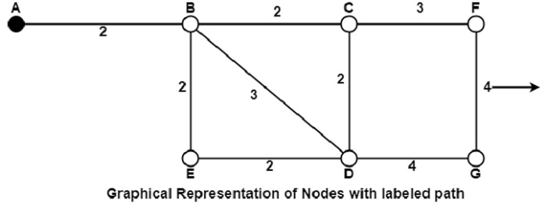
It can be done in various passes as follows, with A as the source.
- Pass 1. B (2, A), C(,), F(,), e(,), d(,), G 60
- Pass 2. B (2, A), C(4, B), D(5, B), E(4, B), F(,),G(,)
- Pass 3. B(2, A), C(4, B), D(5, B), E(4, B), F(7, C), G(9, D)
We can see that there can be two paths between A and G. One follows through ABCFG and the other through ABDG. The first one has a path length of 11, while the second one has 9. Hence, the second one, as G (9, D), is selected. Similarly, Node D has also three paths from A as ABD, ABCD and ABED. The first one has a path length of 5 rest two have 6. So, the first one is selected.
All nodes are searched in various passes, and finally, the routes with the shortest path lengths are made permanent, and the nodes of the path are used as a working node for the next round

BISDN is an extension of ISDN, that is, it has narrowband capability of ISDN but also the broadband capability.
The purpose of BISDN is to achieve complete integration of services, ranging from low-bit- rate burst signals to high-bit-rate continuous real-time signals.

B-ISDN Services
There are two types of B-ISDN services which are as follows
- Interactive Services Two-way exchange of information (other than control signalling information) between two subscribers or between a subscriber and a service provider.
- Distribution Services Primarily one way transfer of information, from service provider to B-ISDN subscriber.
These services are shown in the diagram format below
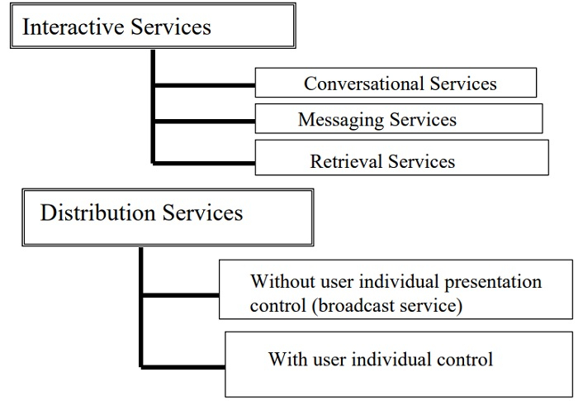
Advertisement

Technology Developments
The key technology developments for B-ISDN are as follows
- Optical fiber transmission systems that can offer low-cost, high-data rate transmission channels for network trunks and subscriber lines.
- The Microelectronic circuits which offer high-speed, low-cost building blocks for switching, transmission, and subscriber equipment.
- High-quality video monitors and cameras that have sufficient production quantities are offered at low cost.

B-ISDN Architecture
The B-ISDN architecture is shown in the diagram below
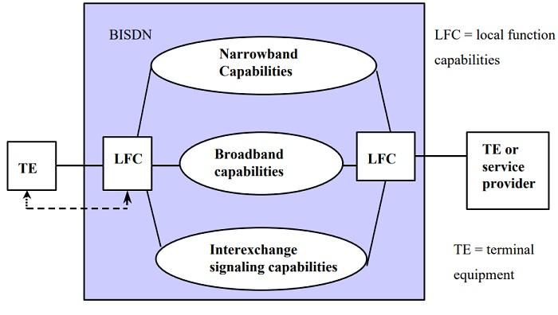
The architecture of the B-ISDN includes low Layer capabilities and high Layer capabilities. These capabilities support the services within the B-ISDN and other networks by means of interworking B-ISDN with those networks.

Low Layer capabilities
The low layer capabilities of B-ISDN architecture are explained below
- From the functional capabilities of the B-ISDN, as shown in Figure, the information transfer capabilities require further description.
- Broadband information transfer is provided by an ATM at the B-ISDN user-network interface (UNI) and at switching entities inside the network.

High Layer capabilities
The high layer capabilities of B-ISDN architecture are explained below
- Normally, the high Layer functional capabilities are involved only in the terminal equipment.
- The support of some services, provision of high layer functions could be made through special nodes in the B-ISDN belonging to the public network or to centres operated by other organizations and accessed via B-ISDN user-network or network node interfaces (NNIs).

Selective-repeat Automatic Repeat Request (ARQ) is one of the techniques where a data link layer may deploy to control errors.

Techniques to Control ARQ
Generally, there are three types of techniques which control the errors by Automatic Repeat Request (ARQ) they are
- Stop-and-wait ARQ
- Go-Back-N ARQ
- Selective Repeat ARQ
Advertisement

Requirements for Error Control
There are some requirements for error control mechanisms and they are as follows
- Error detection The sender and receiver, or any must ascertain that there is some error in the transit.
- Positive ACK Whenever a receiver receives a correct frame, it should acknowledge it.
- Negative ACK Whenever the receiver receives a damaged frame or a duplicate frame, it sends a NACK back to the sender and sender must retransmit the correct frame.
- Retransmission The sender always maintains a clock and sets a timeout period. If an ACK of data-frame previously transmitted does not arrive before the timeout, the sender retransmits the frame, thinking that the frame or its ACK is lost in transit
Let us see the working condition of Selective Repeat ARQ.

Selective Repeat ARQ
It is also known as Sliding Window Protocol and used for error detection and control in the data link layer.
In the selective repeat, the sender sends several frames specified by a window size even without the need to wait for individual acknowledgement from the receiver as in Go-Back-N ARQ. In selective repeat protocol, the retransmitted frame is received out of sequence.
In Selective Repeat ARQ only the lost or error frames are retransmitted, whereas correct frames are received and buffered.
The receiver while keeping track of sequence numbers buffers the frames in memory and sends NACK for only frames which are missing or damaged. The sender will send/retransmit a packet for which NACK is received.

Example
Given below is an example of the Selective Repeat ARQ
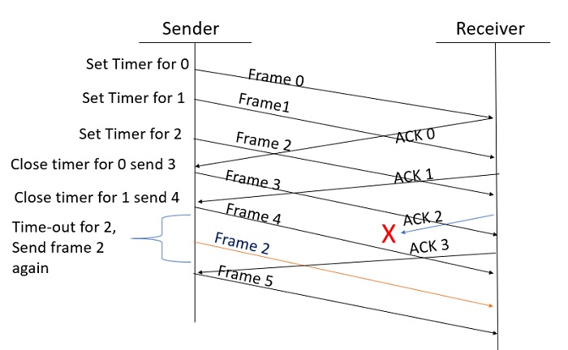

Explanation
Step 1 Frame 0 sends from sender to receiver and set timer.
Step 2 Without waiting for acknowledgement from the receiver another frame, Frame1 is sent by sender by setting the timer for it.
Step 3 In the same way frame2 is also sent to the receiver by setting the timer without waiting for previous acknowledgement.
Step 4 Whenever sender receives the ACK0 from receiver, within the frame 0 timer then it is closed and sent to the next frame, frame 3.
Step 5 whenever the sender receives the ACK1 from the receiver, within the frame 1 timer then it is closed and sent to the next frame, frame 4.
Step 6 If the sender doesnt receive the ACK2 from the receiver within the time slot, it declares timeout for frame 2 and resends the frame 2 again, because it thought the frame2 may be lost or damaged.

Flooding
Flooding is a non-adaptive routing technique following this simple method: when a data packet arrives at a router, it is sent to all the outgoing links except the one it has arrived on.
For example, let us consider the network in the figure, having six routers that are connected through transmission lines.
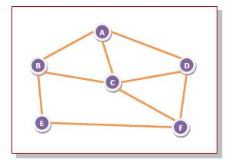
Using flooding technique
- An incoming packet to A, will be sent to B, C and D.
- B will send the packet to C and E.
- C will send the packet to B, D and F.
- D will send the packet to C and F.
- E will send the packet to F.
- F will send the packet to C and E.
Advertisement

Types of Flooding
Flooding may be of three types
- Uncontrolled flooding Here, each router unconditionally transmits the incoming data packets to all its neighbours.
- Controlled flooding They use some methods to control the transmission of packets to the neighbouring nodes. The two popular algorithms for controlled flooding are Sequence Number Controlled Flooding (SNCF) and Reverse Path Forwarding (RPF).
- Selective flooding Here, the routers don't transmit the incoming packets only along those paths which are heading towards approximately in the right direction, instead of every available paths.

Advantages of Flooding
- It is very simple to setup and implement, since a router may know only its neighbours.
- It is extremely robust. Even in case of malfunctioning of a large number routers, the packets find a way to reach the destination.
- All nodes which are directly or indirectly connected are visited. So, there are no chances for any node to be left out. This is a main criteria in case of broadcast messages.
- The shortest path is always chosen by flooding.

Limitations of Flooding
- Flooding tends to create an infinite number of duplicate data packets, unless some measures are adopted to damp packet generation.
- It is wasteful if a single destination needs the packet, since it delivers the data packet to all nodes irrespective of the destination.
- The network may be clogged with unwanted and duplicate data packets. This may hamper delivery of other data packets.

E-mail is represented as the transmission of messages on the Internet. It is one of the most commonly used features over communications networks containing text, files, images, or other attachments.
Format of E-mail An e-mail includes three parts that are as follows

E-mail Envelope
In modern e-mail systems, there is a distinction made between the e-mail and its contents. An e-mail envelope contains the message, destination Address, Priority security level etc. The message transport agents use this envelope for routing.
Advertisement

Message
The actual message inside the envelope is made of two parts
- Header
- Body
The header carries the control information while the Body contains the message contents. The envelope and messages are shown in the figure below
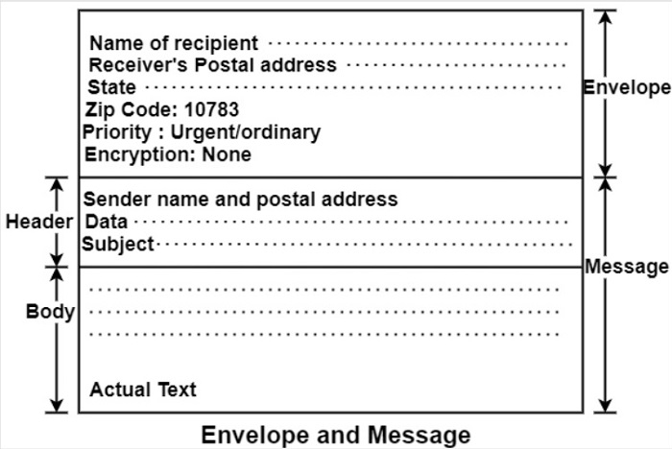

Message Formats
Let us understand the RFC 822 message format in an email.
Messages consist of a primitive envelope, some header fields and a blank line, and the message body. Each header field logically includes a single line of ASCII text which contains the field name, a colon and a field. RFC 822 is an old standard. Usually, the user agent builds a message and passes it to be the message transfer agent with the users header fields to construct an envelope.
The following table shows the principal header fields related to message transport.
RFC 822 header fields related to message transport
Header | Meaning
To | E-mail address of primary recipients.
Cc | E-mail address of secondary recipients.
BCC | E-mail address for blind carbon copies.
From | Person who created the message.
Sender | E-mail address of the actual sender.
Received | Line inserted by each transfer agent along the route.
Return Patch | It can use it to identify the path to the sender.

The To field
The field gives the DNS address of the primary recipient. It is allowed to have multiple recipients.

The Cc field
This field gives the addresses of any secondary recipients.

The Bcc
The long form of Bcc is Blind Carbon Copy. This field is such as the Cc field, except that this is removed from all the copies shared with the primary and secondary recipients. This feature allows people to send copies to third parties without primary and secondary recipients knowing this.

From and Sender fields
These fields tell about who wrote the message and who sent the message, respectively, because the person who creates the message and the person who sends it can be different.
The from the field is required, but the sender field can be omitted if it is the same as the one from the field. These fields are required in case the message is undeliverable and is to be returned to the sender.

Received field
A-line containing the Received field is added by each message transfer agent along the way. This line carries the agents identity, date and time at which they received the message. It also contains some other information that can be used to find bugs in the routing system.

The Return-Path field
The final message transfer agent adds this field, and it is predetermined to tell how to receive back to the sender. It can gather this information from all the received headers.

Other header fields
In addition to the field to table below, RFC 822 messages may contain various header fields used by user agents or human recipients. Many of them are shown in the table below
Some fields in RFC 822 message header are as follows :
Header | Meaning
Date: | The date and time of the message.
Reply To | The E-mail address to which the reply is to be sent.
Message-Id: | Message identifying number
In Reply To: | Message-Id of the message to which this is a reply.
References: | Other relevant messages identifying numbers.
Keywords: | Keywords chosen by users.
Subject: | Summary of the message for the one-line display.
The RFC 822 allows the users to invent new headers for their private use, but these headers must start with the string X Event of the week.

Message Body
The message body comes after the header. The users can put whatever they want to send in the message body. It is possible to terminate the messages with ASCII cartoons, quotations, and political statements.

Cryptography refers to the science and art of transforming messages to make them secure and immune to attacks. It is a method of storing and transmitting data in a particular form so that only those for whom it is intended can read and process it. Cryptography not only protects data from theft or alteration but can also be used for user authentication.

Components
There are various components of cryptography which are as follows

Plaintext and Ciphertext
The original message, before being transformed, is called plaintext. After the message is transformed, it is called ciphertext. An encryption algorithm transforms the plaintext into ciphertext; a decryption algorithm transforms the ciphertext back into plaintext. The sender uses an encryption algorithm, and the receiver uses a decryption algorithm.

Cipher
We refer to encryption and decryption algorithms as ciphers. The term cipher is also used to refer to different categories of algorithms in cryptography. This is not to say that every sender-receiver pair needs their very own unique cipher for secure communication. On the contrary, one cipher can serve millions of communicating pairs.

Key
A key is a number (or a set of numbers) that the cipher, as an algorithm, operates on. To encrypt a message, we need an encryption algorithm, an encryption key, and plaintext. These create the ciphertext. To decrypt a message, we need a decryption algorithm, a decryption key, and the ciphertext. These reveal the original plaintext.
Advertisement

Types
There are two types of cryptography which are as follows

Symmetric Key Cryptography
In symmetric-key cryptography, the same key is used by both parties. The sender uses this key and an encryption algorithm to encrypt data; the receiver uses the same key and the corresponding decryption algorithm to decrypt the data.

Asymmetric-Key Cryptography
In asymmetric or public-key cryptography, there are two keys: a private key and a public key. The private key is kept by the receiver. The public key is announced to the public.
In public-key encryption/decryption, the public key that is used for encryption is different from the private key that is used for decryption. The public key is available to the public, and the private key is available only to an individual.

Casting in computer networks means transmitting data (stream of packets) over a network. Following are the different types of casting used in networking
- Unicast transmission
- Broadcast transmission
- Multicast transmission
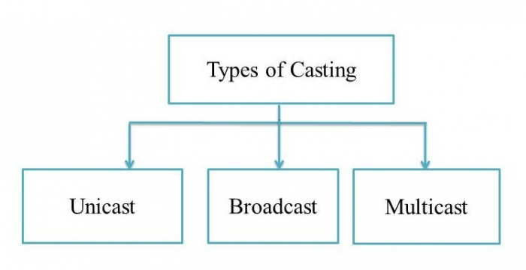

Unicast Transmission (One-to-One)
In Unicast transmission, the data is transferred from a single sender (or a single source host) to a single receiver (or a single destination host).
The network switches hear the MAC addresses of the devices on the networks to which they are connected. They can then forward packets only onto those networks containing devices with the connected MAC addresses. Unicast gradually becomes less efficient as more receivers need to see identical data.

Example
In the following figure, Host A sends the IP address 11.1.2.2 data to the Host B IP address 20.12.4.3.
- Source Address = IP address of host A is 11.1.2.2
- Destination Address = IP address of host B is 20.12.4.3
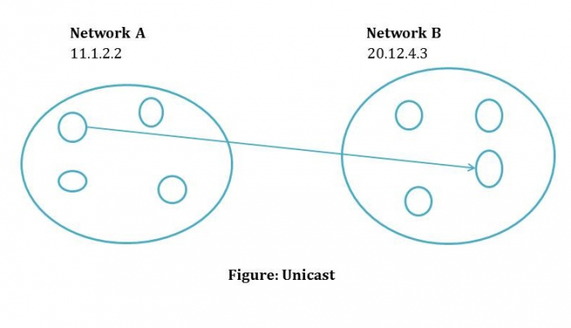
Advertisement

Broadcast Transmission (One-to-All)
In Broadcast transmission, the data is transmitted from one or more senders to all the receivers within the same network or in other networks. This type of transmission is useful in network management packets such as ARP (Address Resolution Protocol) and RIP (Routing Information Protocol) where all the devices must see the data.
There are two types of broadcast transmission
- Directed Broadcast, and
- Limited Broadcast

Directed Broadcast
Directed Broadcast transmits data from one source host to all the other hosts that exist in some other network. It is used in two scenarios
- When the hosts are responsible for parsing data from broadcast packets.
- When all the hosts require the same data.
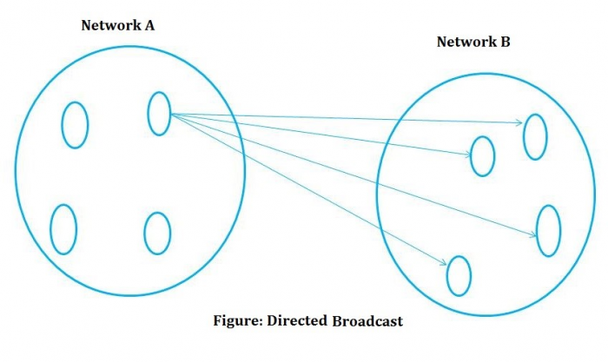

Limited Broadcast
In Limited Broadcast, the data is transmitted from a single source host to all the other hosts residing in the same network.

Multicast Transmission (One-to-Many)
When the data is transmitted from a single source host to a specific group of hosts having the interest to receive the data, it is known as multicast transmission. Multicast can be more efficient than unicast when different groups of receivers need to see the same data.
Example Multicast is the technique used in Internet streaming of video or audio teleconference, sending an email to a particular group of people, etc.
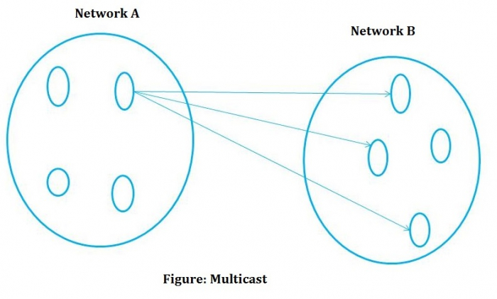

Network Virtualization
Network virtualization represents the administration and monitoring of an entire computer network as a single administrative entity from a single software-based administrators console.
Network virtualization can include storage virtualization, which contains managing all storage as an individual resource. Network virtualization is created to enable network optimization of data transfer rates, flexibility, scalability, reliability, and security. It automates many network management functions, which disguise a network's true complexity. All network servers and services are considered as one pool of resources, which can be used independently of the physical elements.
Virtualization can be defined as making a computer that runs within another computer. The virtual computer, or guest device, is a fully functional computer that can manage the same processes your physical device can. The processes performed by the guest device are separated from the basic processes of your host device. You can run several guest devices on your host device and each one will identify the others as an independent computer.
Advertisement

Advantages of Network Virtualization
The advantages of network virtualization are as follows
- Lower hardware costs With network virtualization, entire hardware costs are reduced, while providing a bandwidth that is more efficient.
- Dynamic network control Network virtualization provides centralized control over network resources, and allows for dynamic provisions and reconfiguration. Also, computer resources and applications can connect with virtual network resources precisely. This also enables for optimization of application support and resource utilization.
- Rapid scalability Network virtualization generated an ability to scale the network rapidly either up or down to handle and make new networks on-demand. This is a valuable device as enterprises transform their IT resources to the cloud and shift their model to an as a service.

Types of Network Virtualization
The types of network virtualization are as follows
- Network Virtualization Network virtualization is a technique of combining the available resources in a network by splitting up the available bandwidth into different channels, each being separate and distinguished.
- Server Virtualization This technique is the masking of server resources. It simulates physical servers by transforming their identity, numbers, processors, and operating frameworks. This spares the user from continuously managing complex server resources. It also makes a lot of resources available for sharing and utilizing, while maintaining the capacity to expand them when needed.
- Data Virtualization This type of cloud computing virtualization technique is abstracting the technical details generally used in data management, including location, performance, or format, in favor of broader access and more resiliency that are directly related to business required.
- Application Virtualization Software virtualization in cloud computing abstracts the application layer, separating it from the operating framework.

Both Flow control and Congestion control are traffic controlling methods in computer networks. Flow control is a technique that allows two stations working at different speeds to communicate with each other. It is a set of measures taken to regulate the amount of data that a sender sends so that a fast sender does not overwhelm a slow receiver.
Congestion occurs in a network when it receives too many packets than its designed capacity. Network congestion occurs in case of traffic overloading. There are mechanisms to control such congestion scenarios in a network.
Go through this article to find out more about Flow Control and Congestion Control and how these mechanisms are different from each other.

What is Flow Control?
Flow control is a system that guarantees a sender's transmission rate is proportional to the receiver's reception capability.
- In data communications, flow control is used to manage the flow of data/packets between two nodes, primarily when the transmitting device can deliver data quicker than the receiver can digest it.
- Many different devices are connected to networks of any size, and each device has its data transmission settings. A router, for example, is designed to manage data routing, whereas a PC on the receiving end of that data has significantly fewer sending/receiving capabilities.
- If the sender begins transferring data quicker than the receiving node's ability, a conflict may arise. Flow control is employed to address this issue. This method controls the data flow between nodes by focusing on both nodes' sending and receiving capabilities.
Xon-Xoff is a flow control protocol that synchronizes the transmitter and receiver. When the receiver's buffer is complete, it sends a transmit-off signal, and when the receiver is ready to retake data, it sends a transmit on the signal. Xon-Xoff uses asynchronous serial connections.
In data link layer, flow control restricts the number of frames the sender can send before it waits for an acknowledgment from the receiver.

Types of Flow Control
Flow control can be broadly classified into two categories
- Feedback-based Flow Control In these protocols, the sender sends frames after it has received acknowledgments from the user. This is used in the data link layer.
- Rate-based Flow Control These protocols have built in mechanisms to restrict the rate of transmission of data without requiring acknowledgment from the receiver. This is used in the network layer and the transport layer.
Advertisement

What is Congestion Control?
When a node or a link carries too much data, it causes queuing delays, frame or data packet loss, and blocking new connections, lowering network service quality. Response time slows as network throughput drops in a congested network. When bandwidth is limited, and data traffic exceeds capacity, congestion develops.
Congestion causes choking of the communication medium. When too many packets are displayed in a method of the subnet, the subnet's performance degrades. Hence, a network's communication channel is called congested if packets are traversing the path and experience delays mainly over the path's propagation delay.
Data packet loss due to congestion is mitigated by aggressive network protocol retransmission, which maintains a network congestion condition after reducing the initial data load. This can result in two stable states under the same data traffic load - one to deal with the initial load and the other to keep the network throughput low.
Avoiding congestion collapse in modern networks requires the use of network congestion avoidance techniques as well as congestion control, such as
- Protocols that use algorithm feedback to reduce data packet throughput to acceptable levels are exponential backoff protocols.
- Prioritization strategies are used to allow only critical data streams to be transmitted.
- Appropriate network resource allocation in anticipation of increased data packet throughput requirements.

Congestion Control Algorithms
There are two congestion control algorithms which are as follows
- Leaky Bucket The leaky bucket algorithm discovers its use in the context of network traffic shaping or rate-limiting. The algorithm allows controlling the rate at which a record is injected into a network and managing burstiness in the data rate.
- Token Bucket Algorithm It is a control algorithm that indicates when traffic should be sent. This order comes based on the display of tokens in the bucket. The bucket contains tokens. Each of the tokens defines a packet of predetermined size. Tokens in the bucket are deleted for the ability to share a packet.

Difference between Flow Control and Congestion Control
The following table highlights the major differences between Flow Control and Congestion Control.
Key | Flow Control | Congestion Control
Definition | Flow Control is a mechanism that controls the traffic in a computer network. Traffic represents the flow of data from the sender to the receiver. | Congestion Control too is a traffic controlling mechanism.
Layers | Data link and Transport layers handle flow control. | Network and Transport layers handle congestion control.
Prime Focus | Receiver is prevented from being overwhelmed. | Network is prevented from being congested.
Responsibility | Only sender is responsible for the traffic. | Transport layer is responsible for the traffic.
How does it work? | Traffic is prevented by slowing down the sender. | Traffic is prevented by slowing down the transport layer.

Conclusion
To conclude, both Flow control and Congestion control are traffic controlling methods in computer networks, however flow control mechanisms prevent the receiver nodes from being overloaded with data, whereas congestion control mechanisms work at the network and transport layers to prevent the overall network from being congested.

Asynchronous Transfer Mode (ATM) in Computer Network
ATM stands for Asynchronous transfer mode. It is a switching technique used by telecommunication networks that uses asynchronous time-division multiplexing to encode data into small, fixed-sized cells. ATMs can be used for efficient data transfer over highspeed data networks. ATM provides real-time and non-real-time services.
Advertisement

Services of ATM
The services provided by ATM are as follows
- Available Bit Rate: It provides a guaranteed minimum capacity, but data can be burst to higher capacities when network traffic is lower.
- Constant Bit Rate: It is used to specify a fixed bit rate so that data is sent in a steady stream. This is analogous to a leased line.
- Unspecified Bit Rate: This doesn't assure any throughput level and is used for applications, including file share that can tolerate delays.
- Variable Bit Rate (VBR): It can provide a determining throughput, but data is not transmitted evenly. This makes it a famous choice for voice and video conferencing.

Benefits of ATM
The high-level benefits delivered through ATM services deployed on ATM technology using international ATM standards can be summarized as follows

Dynamic bandwidth for bursty traffic
Dynamic bandwidth for bursty traffic meeting application needs and delivering a high utilization of networking resources; most applications are or can be viewed as inherently bursty. For example, voice is bursty, as both parties are neither speaking at once nor all the time; video is bursty, as the amount of motion and required resolution varies over time.

Can handle mixed network traffic very efficiently
Variety of packet sizes makes traffic unpredictable. All network types of equipment should incorporate elaborate software systems to manage the various sizes of packets. ATM handles these problems efficiently with the fixed size cell.

Cell network
All information is loaded into identical cells that can be sent with complete predictability and consistency.

Class-of-service
It supports multimedia traffic allowing applications with varying throughput and latency requirements to be met on a single network.

Common LAN/WAN architecture
It allows ATM to be used consistently from one desktop to another; traditionally, LAN and WAN technologies have been very different, with implications for performance and interoperability. But ATM technology can be used either as a LAN technology or a WAN technology.

ATM and ATM Networks
ATM stands for Asynchronous Transfer Mode. It is a switching technique that uses time division multiplexing (TDM) for data communications.
ATM networks are connection oriented networks for cell relay that supports voice, video and data communications. It encodes data into small fixed - size cells so that they are suitable for TDM and transmits them over a physical medium.
The size of an ATM cell is 53 bytes: 5 byte header and 48 byte payload. There are two different cell formats - user-network interface (UNI) and network-network interface (NNI).
Advertisement

Reference Model of ATM
The below image represents the Functional Reference Model of the Asynchronous Transfer Mode:
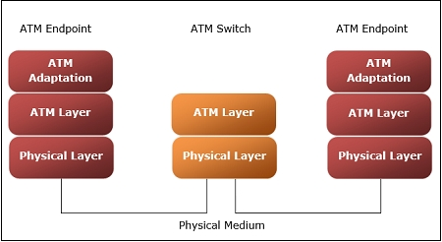

Benefits of ATM Networks
Benefits of ATM networks are:
- It provides the dynamic bandwidth that is particularly suited for bursty traffic.
- Since all data are encoded into identical cells, data transmission is simple, uniform and predictable.
- Uniform packet size ensures that mixed traffic is handled efficiently.
- Small sized header reduces packet overload, thus ensuring effective bandwidth usage.
- ATM networks are scalable both in size and speed.

Layers of ATM Reference Model
ATM reference model comprises of three layers:
- Physical Layer This layer corresponds to physical layer of OSI model. At this layer, the cells are converted into bit streams and transmitted over the physical medium. This layer has two sub layers: PMD sub layer (Physical Medium Dependent) and TC (Transmission Convergence) sub layer.
- ATM Layer This layer is comparable to data link layer of OSI model. It accepts the 48 byte segments from the upper layer, adds a 5 byte header to each segment and converts into 53 byte cells. This layer is responsible for routing of each cell, traffic management, multiplexing and switching.
- ATM Adaptation Layer (AAL) This layer corresponds to network layer of OSI model. It provides facilities to the existing packet switched networks to connect to ATM network and use its services. It accepts the data and converts them into fixed sized segments. The transmissions can be of fixed or variable data rate. This layer has two sub layers Convergence sub layer and Segmentation and Reassembly sub layer.
- ATM endpoints It contains ATM network interface adaptor. Examples of endpoints are workstations, routers, CODECs, LAN switches, etc.
- ATM switch It transmits cells through the ATM networks. It accepts the incoming cells from ATM endpoints (UNI) or another switch (NNI), updates cell header and retransmits cell towards destination

Both Synchronous and Asynchronous Transmission are types of serial data transmission techniques in which data is transmitted between the sender and the receiver based on a clock pulse used for synchronization.
Read through this article to find out more about synchronous and asynchronous transmission and how they are different from each other.

What is Synchronous Transmission?
Synchronous transmission is a technique of data transmission in which a sender transmits a continuous stream of data along with periodic timing signals supplied by an external clocking system in order to ensure that the transmitter and the receiver are in sync.
In Synchronous transmission, data is transferred at predetermined intervals based on a predefined clocking signal. It is intended for the consistent and reliable transmission of time-sensitive data such as VoIP and audio/video streaming.
Because data is delivered in huge blocks rather than individual characters, this type of transmission method is employed when huge volumes of data need to be transferred quickly. It can provide real-time communication between a transmitter and a receiver.
The data blocks are separated and clustered at regular intervals, with synchronous characters preceding them that a remote device decodes and uses to synchronize the connection between the endpoints.
Advertisement

What is Asynchronous Transmission?
In Asynchronous transmission, each character is a self-contained unit with its start and stop bits and an unpredictable delay. Hence, this form of transmission is also known as "start/top transmission".
The beginning and ending bits of asynchronous transmission are represented by start and stop bits. At the beginning and end of a transmission, the extra 1 notifies the receiver of the first and last characters being sent.
In asynchronous transmission method, data is transferred as packets rather than a continuous stream. Since the start and stop bits are polarized in the opposite direction, the receiver can tell when the second packet of data has been sent.
The following are the two main characteristics of asynchronous communication
- A start bit precedes each character, and one or more stop bits follow it.
- Spaces frequently separate characters.
Asynchronous transmission, in general, has slower transmission rate, however it is highly flexible because it does not require the transmitter and receiver to be synchronized.

Difference between Synchronous and Asynchronous Transmission
The following table highlights the major differences between Synchronous and Asynchronous Transmission
Key | Synchronous Transmission | Asynchronous Transmission
Definition | Synchronous transmission is the type of transmission in which a common clock pulse is shared between the transmitter and the receiver in order to permit synchronized communication. | Asynchronous transmission is the type of transmission in which the sender and the receiver have their own internal clocks; thus they do not need an external common clock pulse.
Data Unit | In Synchronous transmission, data is sent in the form of frames or blocks so the data unit is Frame/block. | In Asynchronous transmission, data is transmitted in the form of bytes or characters, so the data unit is byte/character.
Time Intervals | The time interval between two consecutive transmissions is constant in synchronous transmission. | In asynchronous transmission, the time interval between two consecutive transmissions is random.
Performance and Cost efficiency | Synchronous transmission is a quick process. Due to the implementation of common clock pulse in Synchronous transmission, the transmission of data is faster as compared to that in Asynchronous transmission but it makes this form of transmission costlier. | It takes a long time for asynchronous transmission to complete. In Asynchronous transmission, each sender and receiver has their own input clocks, hence the transmission depends on its synchronization. So it is slower as compared to Synchronous transmission but at the same time, significantly inexpensive.
Complexity | It is easy to design Synchronous transmission. | Asynchronous transmission is complex in nature and design.
Data Gap | Due to the common clock pulse in Synchronous transmission, there is no gap present between data. | In Asynchronous transmission, there is gap present between the data bytes. It contains start bits and end bits in the middle of which actual data is present.

Conclusion
The most important point that you should note here is that, data is transmitted as a continuous stream in synchronous transmission, while in the asynchronous transmission method, data is transferred as discrete chunks of packets.
Synchronous transmission requires carefully synchronized clocks for the transmission of data, whereas asynchronous transmissions do not require synchronized clocks because the parity bits convey the information about data bytes.

A network attack is any attempt to disrupt, compromise or gain unauthorized access to a computer network or its resources. Network attacks can be classified into several categories, depending on the method used, the target and the intent of the attacker.
One way to classify network attacks is by their intent. Some attacks are designed to disrupt the normal operation of a network or its resources, while others are designed to steal sensitive information or take control of network resources.
Another way to classify network attacks is by the method used. Some attacks involve exploiting known vulnerabilities in network software or hardware, while others use social engineering techniques to trick users into revealing sensitive information.
A few examples of network attacks include
- Denial of Service (DoS) attacks
- Distributed Denial of Service (DDoS) attacks
- Phishing attacks
- Sniffing attacks
- Malware attacks
- Remote code execution attacks

Denial of Service (DoS) attacks
A Denial of Service (DoS) attack is an attempt to make a network resource or service unavailable to legitimate users by overwhelming it with traffic from multiple sources. The goal of a DoS attack is to disrupt the normal operation of a network or website, making it unavailable to legitimate users.
DoS attacks can be launched from a single machine or from a distributed network of compromised machines, known as a botnet. These attacks are relatively easy to launch and can cause significant disruption, even if the attack is not particularly sophisticated.
Advertisement

Distributed Denial of Service (DDoS) attacks
A Distributed Denial of Service (DDoS) attack is a type of attack that is similar to a Denial of Service (DoS) attack, but it uses a distributed network of compromised machines to generate traffic to overwhelm a target. This makes DDoS attacks much more difficult to defend against than traditional DoS attacks because the traffic is coming from multiple sources, making it difficult to distinguish legitimate traffic from attack traffic.
In a DDoS attack, an attacker infects a large number of computers with malware, creating a botnet, and then uses this botnet to generate a large amount of traffic directed at a target, such as a website or a network. The traffic can come in many forms, including HTTP requests, ICMP packets, and UDP traffic, among others. The goal is to saturate the network and resources of the target, making it unavailable to legitimate users.

Phishing attacks
Phishing is a type of social engineering attack that attempts to trick individuals into revealing sensitive information, such as login credentials or financial information. The goal of a phishing attack is to steal sensitive information or gain unauthorized access to a user's accounts or devices.
Phishing attacks typically take the form of an email or a message, often purporting to be from a legitimate organization, such as a bank or a well-known company. These messages often include a link to a fake website or a request for sensitive information.

Man-in-the-middle (MitM) attacks
A Man-in-the-Middle (MitM) attack is a type of attack in which an attacker intercepts and modifies network traffic between two parties without their knowledge. In a MitM attack, the attacker is able to read, insert and modify the content of the traffic between the communication parties. This can allow the attacker to steal sensitive information, such as login credentials, financial information, or other sensitive data.

Sniffing attacks
A sniffing attack is a type of network attack that involves intercepting and analyzing network traffic in order to extract sensitive information. A sniffer, also known as a packet sniffer or network analyzer, is a tool or software used to capture and analyze network packets. Attackers use sniffing tools to capture and analyze network traffic in order to steal sensitive information, such as login credentials, financial information, or other sensitive data.

SQL injection
SQL injection is a type of attack that exploits vulnerabilities in the SQL code of websites or web-based applications. It is a technique used to take advantage of improper coding of web applications that allows an attacker to insert malicious SQL statements into the input fields of a web application, which are then executed by the back-end database.
An attacker can use SQL injection to gain unauthorized access to a database, steal sensitive information, modify or delete data, or even execute arbitrary system commands on the server.

Remote code execution attacks
A Remote Code Execution (RCE) attack is a type of attack that allows an attacker to execute arbitrary code on a remote system. This can allow the attacker to take control of the system, steal sensitive information, or cause damage to the system and its resources.
RCE attacks typically involve exploiting vulnerabilities in software or systems, such as unpatched software, weak or easily guessable passwords, or poor system configurations. Once the attacker has gained access to a system, they can use various techniques to execute code and take control of the system.

Conclusion
In conclusion, network attacks are a serious threat to the security of computer networks and their resources. These attacks can have serious consequences, including the disruption of normal network operations, the loss of sensitive information, and the compromise of important systems and resources. There are many different types of network attacks, each with their own unique characteristics and methods, such as: Denial of Service (DoS) and Distributed Denial of Service (DDoS) attacks, Phishing attacks, Man-in-the-middle (MitM) attacks, Sniffing attacks, SQL injection and Remote code execution attacks

What is WiMAX?
WiMAX stands for "Worldwide Interoperability for Microwave Access," a telecommunications standard that describes fixed and fully mobile Internet access services. The protocol follows some aspects of the IEEE 802.16 Standard.
WiMAX products and services are most likely to be found in "last mile" applications. WiMAX enables ISPs and carriers to deliver Internet access to homes and businesses without the need for physical cabling (copper, cable, etc.) to reach the customer's location.
Advertisement

Difference between WiMAX and WiFi
WiMAX is sometimes compared to WiFi because both technologies rely on wireless Internet connectivity and are complementary.
Following are some of the major differences between WiMAX and WiFi
- WiMAX's range is measured in kilometers, but WiFi's range is measured in meters and is only available locally. The reliability and range of WiMAX make it ideal for providing Internet access to significant urban areas.
- WiFi uses an unlicensed spectrum, whereas WiMAX uses a licensed or unlicensed band.
- WiFi is increasingly being used by end-user devices such as laptops, desktops, and cellphones. As a result, WiMAX service providers typically give a WiMAX subscriber unit to the consumer. This device connects to the provider's network and provides customers with WiFi access and convenience inside the WiFi range.

Architecture of WiMAX
- The physical layer The physical layer is in charge of signal encoding and decoding and bit transmission and receiving. It turns MAC layer frames into transmittable signals. QPSK, QAM-16, and QAM-64 are some of the modulation methods utilized on this layer.
- MAC Layer This layer serves as a link between the WiMax protocol stack's convergence and physical layers. It is based on CSMA/CA and allows point-to-multipoint communication (Carrier Sense Multiple Access with Collision Avoidance).
- Convergence Layer This layer provides information from the external network. It takes higher-layer protocol data units (PDUs) and converts them into lower-layer PDUs. It has different functions depending on whatever service is used.

Advantages of WiMAX
WiMAX offers the following benefits
- It allows for very high-speed voice and data transmission over extended distances.
- Hundreds of users can be served by a single WiMAX BS.
- It is seen as a less expensive alternative to broadband wired technologies such as ADSL, cable modem, etc.
- Higher speeds are possible.
- With mobile WiMAX, you can get a more comprehensive coverage range and cellular-like performance.

Disadvantages of WiMAX
WiMAX has the following drawbacks
- Subscribers located far away from the WiMAX BS require a LOS (Line of Sight) connection.
- Bad weather, such as rain, will disrupt the WiMAX signal and frequently result in a loss of connection.
- Wimax is a power-hungry technology that necessitates a lot of electrical assistance.
- It is not backward compatible with any wireless cellular technologies, so the initial cost of starting a WiMax is very high.
- WiMax BS and towers must be set up from scratch. Since skilled workforce is needed, it results in significant starting expenses and higher operational expenditures.

Buffering refers to the process of temporarily storing data in memory (a buffer) before it is sent or received over a network. The buffer helps to smooth out any variations in the rate at which data can be sent or received, and ensures that the sender and receiver can work at their own pace without interruption. For example, when streaming a video, the video player may buffer some of the video before it starts playing. This is done so that if the network connection is slow, the video can continue playing without interruption. Similarly, when a computer is sending data over a network, it may buffer the data before sending it to prevent the network from becoming overloaded.

What is Buffering?
Buffering refers to the act of loading data into a temporary storage area, called a buffer, before it is used or processed. This is done to ensure that data can be processed smoothly, even if the rate at which it is received or generated varies.
There are two main types of buffering: input buffering and output buffering.
Input buffering occurs when data is received faster than it can be processed and it is temporarily stored in a buffer until it can be used.
Output buffering occurs when data is generated faster than it can be sent or written to storage, so it is temporarily stored in a buffer until it can be sent or written.
Buffering is used in a variety of computer systems and applications, such as computer networks, audio and video playback, and data storage systems.
It helps to smooth out variations in data transfer and ensure that data is processed efficiently and without interruption.
Advertisement

Types of Buffering
There are several types of buffering, including
- Input buffering This type of buffering occurs when data is received faster than it can be processed, so it is temporarily stored in a buffer until it can be used.
- Output buffering This type of buffering occurs when data is generated faster than it can be sent or written to storage, so it is temporarily stored in a buffer until it can be sent or written.
- Line buffering This type of buffering occurs when data is read from or written to a device, such as a terminal or a printer, one line at a time.
- Block buffering This type of buffering occurs when data is read from or written to a device in blocks, rather than one character at a time.
- Double buffering This type of buffering is used in computer graphics, it is a technique where you render graphics to an off-screen buffer and then swap it with the on-screen buffer, avoid flickering issue.
- Circular Buffering This type of buffering is used in communication systems where an array is being used as a buffer. It is called circular buffering, because when the end of the buffer is reached, the next data is written at the beginning, thus overwriting the oldest data.
- Stream buffering This type of buffering is used when working with data streams, such as network streams or file streams. The data is read from or written to the buffer in a streaming fashion, rather than all at once.
These are the commonly used buffering types, there may be other specific types based on the requirement of the system.

Need of Buffering
Buffering is used to smooth out variations in the rate at which data is received or generated, and to ensure that data is processed efficiently and without interruption. There are several reasons why buffering is necessary
- Speed mismatches In many computer systems and applications, data is received or generated at different rates. For example, a network connection may be faster than the rate at which data can be processed by the computer, or data may be generated faster than it can be written to storage. Buffering helps to mitigate these speed mismatches by temporarily storing data in memory.
- Network congestion When sending data over a network, it is important to avoid overwhelming the network with too much data at once. Buffering helps to prevent network congestion by temporarily storing data in memory before it is sent.
- Error handling Buffering can also be used to help handle errors that may occur when transmitting or processing data. For example, if an error occurs while sending data over a network, the data can be retransmitted from the buffer rather than being lost.
- Synchronization Buffering also helps to synchronize different processes that may be running simultaneously. For example, when video is being streamed, the video player may buffer some of the video before it starts playing. This ensures that the video can continue playing without interruption even if the network connection is slow.
- User Experience Buffering allows for smooth experience for the user. For example, in video streaming, if buffering is not implemented, video can freeze or get buffered frequently which can be annoying for the user.
- Power optimization buffering allows the system to work at its own pace and avoid power consumption while fetching or sending large chunks of data.

How Buffering is Important?
Buffering is an important technique for ensuring the efficient and smooth operation of a wide range of computer systems and applications. Some of the ways in which buffering is important include
- Maintaining the performance and throughput of computer systems Buffering helps to ensure that data can be processed smoothly, even if the rate at which it is received or generated varies. This can improve the overall performance and throughput of a computer system.
- Improving the quality of user experience Buffering helps to ensure that data can be processed and delivered to the user without interruption. This can improve the quality of the user experience, especially in applications such as video streaming and online gaming.
- Ensuring data integrity and reliability Buffering can also be used to help ensure the integrity and reliability of data transmission and storage. For example, if an error occurs while sending data over a network, the data can be retransmitted from the buffer rather than being lost.
- Optimizing power consumption Buffering can be used to limit the amount of data that needs to be transferred at any given time, thus reducing power consumption for devices.
- Facilitating effective communication Buffering allows data to be temporarily stored before it is sent or received, which can help to prevent network congestion and ensure that data can be transmitted or received efficiently.
- Supporting multiple processes Buffering can also be used to synchronize different processes that may be running simultaneously, which can improve the overall performance and functionality of a computer system.
Overall, Buffering is a crucial technique that is essential for ensuring efficient, smooth, and reliable operation of computer systems and applications.

